METHOD VALIDATION AND UNCERTAINITY MEASURMENTS PROCEDURE

- PURPOSE

Typically every testing or calibration measurement has an error. Therefore a measurement only gives an approximation of the true value of the quantity to be measured. The possible difference to the true value, or the measurement uncertainty, should be estimated and reported as part of any good analytical practice. This SOP addresses the process for estimating and documentation of measurement uncertainty.

2.0 SCOPE

The procedure also explains the technical arrangements as per the requirements of the ISO 17025.The SOP covers the estimation and reporting of uncertainty of chemical testing.

3.0 REFERENCES:

- AQL.QM-001
- ISO/IEC 17025
- ISO/IEC 17000
- ISO 9001:2015
- EURACHEM/CITAC Guide CH 4, Quantifying Uncertainty in Analytical Measurement, 2nd Edition, 2000.
- EA-4/02: Expression of the Uncertainty of Measurement in Calibration.
- EA-4/16 G: 2003-EA guidelines on the expression of uncertainty in quantitative testing.

3.0 ABBREVIATIONS / TERMS USED

Abbreviations given in QM apply

  - The terms used in Quality manual (AQC.QM) and ISO 17000 shall apply.
  - Standard Operating Procedure (SOP) – a procedure adopted for repetitive use when performing a specific test.
  - Technical Manager (TM).
  - Quality Manager (QM).

4.0 RECORDS OF CHANGE

NO. | Date | Details of changes |  | Title/ Name | Signature
 | (dd-mm-yyyy) | Page | Clause/Sub-clause and comment | By:
01 | 28/07/2021 | All | • Included Tables and Appendices on the footer note  • Changed Version No. from 00 to 01 | QM

5.0 DISTRIBUTION TABLE

The controlled copies of this document are issued in accordance with appendix C.

DOC. COPY NO. | DOC. VERSION
01 | 01 | QUALITY MANAGER
02 | 01 | TECHNICAL MANAGER
03 | 01 | ACCREDITATION BODY (KENAS)
6.0 GLOSSARY / TERMINOLOGIES

Item | Explanation
(Measurement) Uncertainty | Parameter associated with a result of a measurement that characterizes the dispersion of the values that could reasonably be attributed to the measurement. (Reference 1).
Standard Uncertainty | Uncertainty of the result x of a measurement expressed as a standard deviation (Reference 1).
Combined Standard Uncertainty | Standard uncertainty of a result y of a measurement when the result is obtained from the values of a number of other quantities, equal to the positive square root of a sum of terms, the terms being the variances or co-variances of these other quantities weighted according to how the measurement result varies with these quantities (Reference 1).
Expanded Uncertainty | Quantity defining an interval about the result of the measurement that may be expected to encompass a large fraction of the distribution of values that could reasonably be attributed to the measurement (Reference 1).
Coverage Factor | Numerical factor used as a multiplier of the combined standard uncertainty in order to obtain an expanded uncertainty (Reference 1).
Traceability | The property of the result of a measurement of the value of a standard whereby it can be related to stated references, usually national or international standards, through an unbroken chain of comparisons all having stated uncertainties (Reference 1).
True Value | Value consistent with a definition of a given particular quantity (Reference 1).
Error (of a measurement) | The result of a measurement minus the true value of the measurement (Reference 1).
Random Error | The result of a measurement minus the mean that would result from an infinite number of measurements of the same measurement carried out under repeatability conditions (Reference 1).
Systematic Error | Mean that would result from an infinite number of measurements of the same measurement carried out under repeatability conditions minus a true value of the measurement (Reference 1).

- PRINCIPAL RESPONSIBILITIES

  - ANALYST/TECHNICIAN
    - Collect measurement data to estimate measurement uncertainty.
    - Estimate measurement uncertainty.
    - Report measurement uncertainty for routine analysis/calibration.
  - TECHNICAL MANAGER
    - Prepares a list of tests that require estimation and reporting of measurement uncertainty.
    - Reviews uncertainty data experiments, evaluations and reports.
  - QUALITY MANAGER
    - Advises on regulations and guidelines related to measurement uncertainty.
    - Checks if processes and documentation are in compliance with internal policies and quality standards/guidelines.
    - Reviews and approves measurement uncertainty data as part of the review of test results.

8.0 FLOW CHART

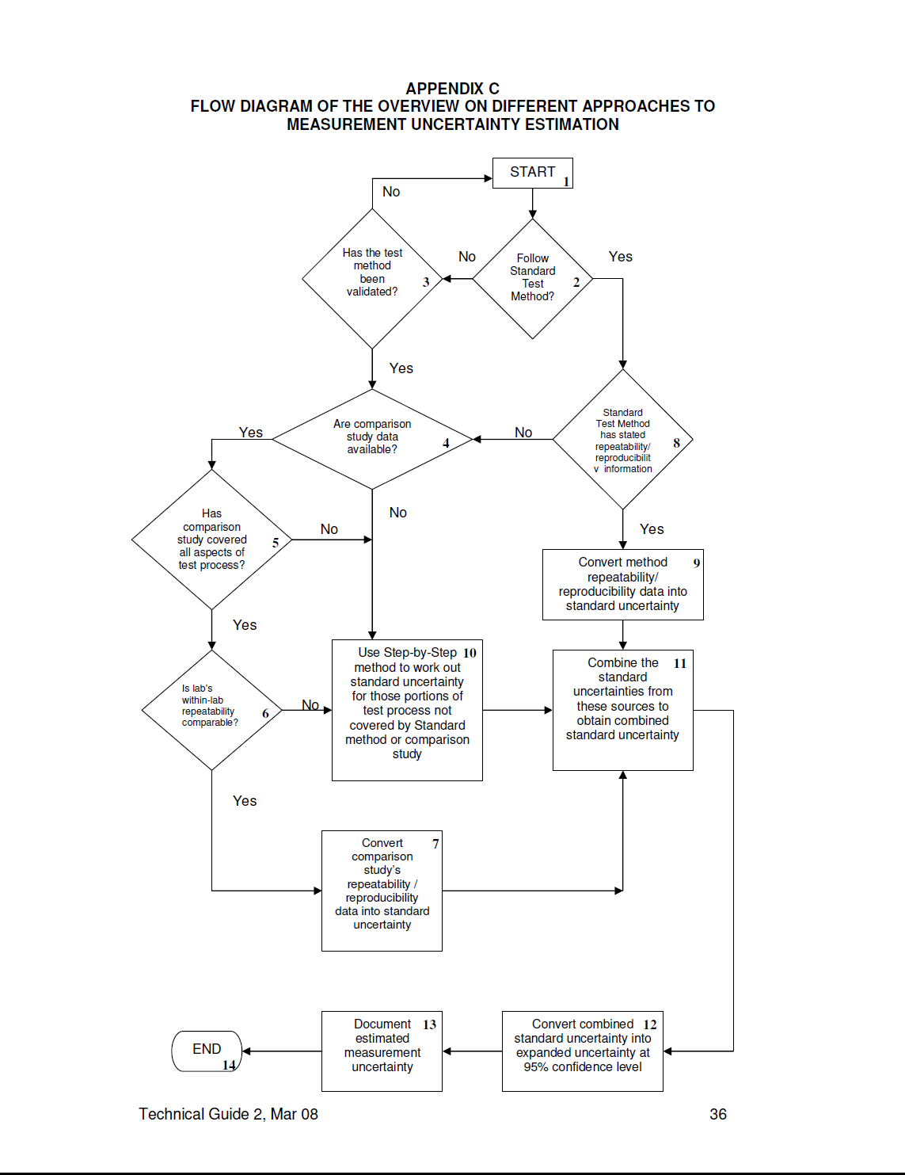

- PROCEDURES
9.1 Determine Tests that Require Estimation of Measurement Uncertainty

    - The laboratory supervisor proposes tests that require estimation and reporting of measurement uncertainty. In general these include:
    - Well-recognized quantitative test methods that specify limits to the values of the major sources of uncertainty of measurement and specify the form of presentation of calculated results.
    - All other quantitative test methods including standard methods and methods developed in-house.
    - All tests where reporting of measurement uncertainty is required by clients.
    - Quality Assurance reviews and approves the list.
  - Document Methods and Specifications
    - For methods as defined in the analyst documents the method and specifications.
This includes:
- Scope of the method.
- Equipment used to run the method.
- Performance acceptance criteria.
- Laboratories where the method is used.
- Required measurement uncertainty data.
  - Identify Uncertainty Sources
    - The analyst collects and documents information on possible sources of uncertainty. The following sources should be considered
- Calibration control standards/reference standards.
- Sampling, sample storage and sample disposal.
- Instruments, equipment and apparatus (bias, error, precision).
- Reagent purity, reference standards, reference materials.
- Environmental and measurement conditions.
- Cross-Contamination, carry over.
- Computational effects (calibration model).
- Sample effects (matrix).
    - The list is reviewed and approved by the Quality Assurance Manager.
  - Define Experiments
    - The analyst suggests a list of experiments to be executed to get uncertainty estimates. Depending on findings from 9.2 and 9.3 the following should be considered:
- Single laboratory short-term precision.
- Single laboratory day-by-day precision.
- Precision within multiple laboratories.
- Recovery studies through comparison with certified reference material.
- Recovery studies through spiking blank and sample matrix reference material.
    - The list is reviewed and approved by the laboratory supervisor.
  - Define other Sources of Uncertainty
    - The analyst suggests a list of other sources that can contribute to uncertainty. Depending on findings from 9.2 and 9.3 the following should be considered:
- Uncertainty of certified reference material as reported in the certificate as supplied by the supplier.
- Purity of reagents as found in the supplier’s catalogue.
    - The laboratory supervisor reviews and approves the list.
  - Conduct Experiments and Evaluate Results
    - For each experiment defined and approved in 9.4 the analyst conducts the experiments.
    - For each experiment a minimum of ten analyses are performed.
    - The analyst calculates analyte recovery and the standard deviation of precision studies for each experiment.
  - Calculate Combined Standard and Expanded Measurement Uncertainty
    - Using data from 9.5 and 9.6.3 the analyst calculates the combined standard uncertainty data using the formula:
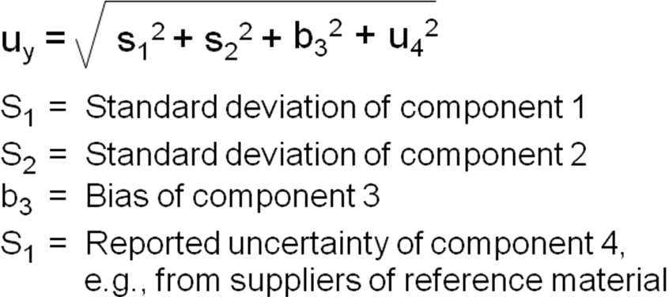
    - Using results from 9.7.1 the analyst calculates the expanded uncertainty formula:
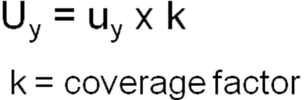
Unless otherwise specified a capacity factor of 2 is used that gives a 95% confidence interval.
  - Report Results
    - The analyst reports the results. The following general recommendations should be considered:
- Present sufficient information to allow the result to be re-evaluated.
- Document the details on how measurement uncertainty has been determined.
- Describe the methods used to estimate measurement uncertainty.
- Document all values and the sources of all assumptions and corrections.
- List all components of uncertainty.
- Limit the numerical values of uncertainty to two digits.
    - Unless otherwise specified the analyst reports numerical values following the guidelines for reporting expanded uncertainty:
    - Reports are signed by the analyst/technician.
  - Review of Experiments, Evaluations and Reports
    - Experiments, evaluations and reports are reviewed and approved by the laboratory supervisor or delegate.
    - Experiments, evaluations and reports are reviewed and approved by the QA manager or delegate management representative.

- APPENDICES

10.1 Appendix A: format of testing method validation form.
10.2 Appendix B: uncertainty measurement for testing form.
10.3 Appendix C: Distribution list of controlled documents.

10.1 APPENDIX A: FORMAT OF TESTING METHOD VALIDATION FORM.

Data record for PH and EC Distilled water weekly Checks
Date | Buffer Solutions |  |  |  |  |  | Variance | EC Standards |  |  | Variance | Analyst Name | Checked by
 | PH 4 | Values | PH 7 | values | PH 10 | values |  | 1413 (µS/cm) | values
 |  |  |  |  |  |  |  |  |  | MEAN
 |  |  |  |  |  |  |  |  |  | SD
 |  |  |  |  |  |  |  |  |  | Su
 |  |  |  |  |  |  |  |  |  | Exp Su
 |  |  |  |  |  |  |  |  |  | UCL
 |  |  |  |  |  |  |  |  |  | LCL
AQC.QP2-F9
10.2 APPENDIX B: FORMAT OF ESTIMATION OF UNCERTAINTY MEASUREMENTS FORM

Uncertainty Measurements Source | Value(+-) | Probability Distribution | coverage factor (Divisor) | Uncertainty Contribution in K
Reference equipments/standards bias |  | Normal
Analyst/technician(test method) errors |  | Rect.
Cal. Standard balance weight error |  | Normal
Repeatability of Standard mass error |  | Normal
Resolution of Standard mass |  | Rect.
Drift Gradient of the mass |  | Rect.
Repeatability of mass |  | Normal
Resolution Of mass |  | Normal
Weight loss due to balance sensor type K
Combined uncertainty (Cu)
K=2@95% CL
Expanded uncertainty
AQC.QP2-F1
Coverage factors:
68% level of confidence: coverage factor (k =1)
95% level of confidence: coverage factor (k=2 )
99% level of confidence: coverage factor (k=2.6)
99.7% level of confidence: coverage factor (k=3)
The uncertainty value should be reduced to one standard uncertainty by dividing it by the coverage factor and the uncertainty (now at a coverage factor of k=2) recorded in the ' uncertainty contribution (k=2)' column.
The uncertainty associated with these measurements is ±0.37

Standard deviation, $σ=\sqrt{\frac{1}{N}}\sum_{i=1}^{N}{(x_{i}-μ)^{2}}$

Standard uncertainty, µ =1*σ

The acceptance criteria (criteria limit):=$\left(Xref-Xuut\right)<2µC$

Where: $Xref-standardreading$
$Xuut-unitundertestreading$
Combined uncertainty = µC

10.3 APPENDIX D: – DISTRIBUTION LIST OF CONTROLLED DOCUMENTS

DOC. COPY NO. | DOC. VERSION
01 | 01 | QUALITY MANAGER
02 | 01 | TECHNICAL MANAGER
03 | 01 | ACCREDITATION BODY (KENAS)

-End of document-

